1. **Are the HTML tags and elements the same thing?**

No, HTML tags and elements are not the same thing.

* HTML tags: - tags are the markup characters that are used define the structure and elements within HTML. Document. They are written in angular brackets (<>). Tags are indicate the beginning and end of an element.
* For example: -



* Elements: -An HTML element consists of an opening tag, content, within an HTML document.
* For example: -

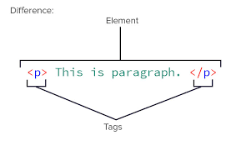

1. What are tags and attributes in HTML ?
   * Both tags and attributes play crucial roles in defining the structure and appearance of web content :

* Tags:- in html, HTML tags are like keywords which defines that how web browser will format and display the content.
  + - For example:-



* Attribute :- Attributes provide additional informance about HTML elements and modify their behaviour or appearance.
* For example: - 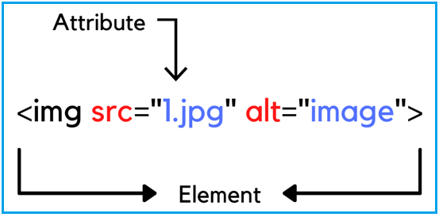

1. What are void elements in HTML? With example.

* Void elements in HTML are elements that do not have any content and do not require a closing tag.
* Void elements are used to insert content or elements that do not require any inner text or nested elements.
* For example: -

This example of void tag(img)



4. What are HTML entities?

With example

* HTML entities are special codes used to represent characters that have special meanings in HTML, such as reserved characters.
* Each of these codes starts with an ampersand and ends with a semicolon.

1. For example :-

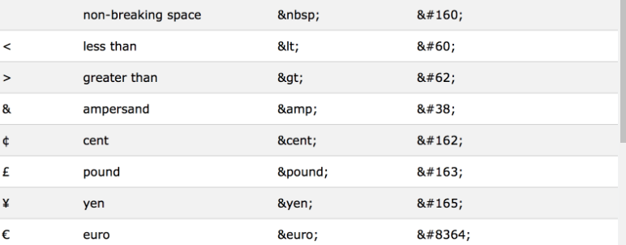

5. What are different types of lists in HTML? with example.

* In HTML, there are three types of lists.

**1 . Ordered Lists**

**2. Unordered Lists**

**3. Definition Lists**

1. **Ordered lists<ol></ol>:**

Ordered lists are used to present information in a numbered sequence.

1. 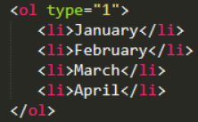For Example :

* Output:-   
   1.January

2.February

3.March

4.April

1. Unorder Lists <ul></ul>:-

Unordered lists are used to present information in bulleted list format. Each list item is marked with a bullet point by default.

* 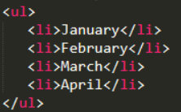For example:-

­

* Output:
* January
* February
* March
* April

1. Definition Lists<dl></dl>:

* Definition lists are used to present terms and their.
* Corresponding definitions. Each terms is wrapped in <dt> (definition terms), and each definition is wrapped in<dd> (definition description).
* **For example:-**

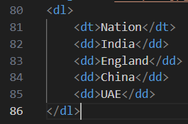

* **Output :-**

Nation

India

England

China

UAE

**6. What is the “class” attribute in HTML? With example.**

* In HTML, the class attribute is used to assign one or more class names to an element. The class attribute is mostly used to point to a class in a style sheet.
* For example:-



1. **What is the difference between the ‘id’ attribute and the ‘class’ attribute of HTML elements? With example**

* In HTML, both the id and class attributes are used to uniquely identify elements, but they serve different purpose:
* **Id Attribute:-**

The id attributes is used to uniquely identify an element within document.it must be unique throughout the entire HTML document. This means that no two elements can have the same id attribute within the same HTML document.

* **For example**:-



* **Class Attribute:-**

The class attributes specifies one or more class names for an element. The class attributes is mostly used to point to a class in style sheet.

* **For example**:-

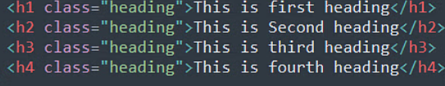

1. **What are the various formatting tags in HTML?**

* In HTML, formatting tags are used to structure and style the content of a webpage. These tags allow you to control the appearance of text, images, and other elements.
* Some commonly used formatting tags in HTML

1. Heading tags <h1> to <h6>
2. Paragraph tag <p></p>
3. Bold tag <B>
4. Italic tag <I>
5. Underline tag <U>
6. Superscript tag <sup>
7. Subscript tag <sup>
8. **How is cell padding different from cell spacing? With example.**

* Cell padding and cell spacing are attributes used in html table elements to control the spacing between the content of cells and the spacing between the content of cells and the spacing between cells themselves.

1. **Cell padding:-**

* Cell padding refers to the space between the content of a cell and its border.
* It is specified using the cell padding attributes of the <table>tag.
* Cell padding adds space inside each cell, creating a gap between the cell’s content and its border.
* **For example:-**

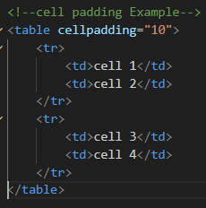

* **Output:-**

**2.Cell spacing:-**

* Cell spacing refers to the space between cells in a table.
* Cell spacing adds space between adjacent cells, creating a gap between them.
* **For example:-**

* **Out put:-**

­­

1. **How can we club two or more rows or columns into a single row or column in an HTML table? With example.**

* In HTML tables, you can merge two or more adjacent rows or column into a single row or column using the rowspan and colspan attributes,

Respectively. These attributes allow you to span multiple rows or columns with a single cell.

* **For example**:-

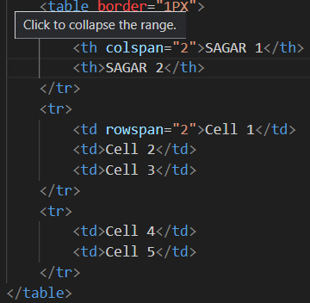

* **Output:-**

1. **What is the difference between a block-level element and an inline element?**

* Block-level elements and inline elements are two fundamental types of elements in HTML, and they behave differently in terms of their rendering and placement within a document.
* **Block-level Elements:-**
* Block-level elements typically start on a new line and occupy the full width available to them.
* They create a “block” of content that stretches horizontally to fill its container.
* You can apply width, height, margin, padding, and border to block-level elements.
* **Inline Elements :-**
* Inline elements do not start on a new line and only occupy the width necessary to contain their content.
* They flow within the text and do not create line breaks.
* Inline elements can be nested within block-level elements.

1. **How to create a Hyperlink in HTML? with example.**

* In HTML, you can create hyperlink using the <a> (anchor) element. Hyperlinks are used to link one web page to another, or to link to different sections within the same web page.
* **For example: -**



1. **What is the use of an iframe tag?**

**With example.**

* An inline frame is a HTML element that loads another HTML page within the document. It essentially puts another webpage within the parent page.
* Hey are commonly used for advertisement, embedded videos, web analytics and interactive content.
* **For example: -**

1. **What is the use of a span tag? Explain with example.**

* In HTML, the span tag is a generic inline container element. You use this element to wrap sections of text for styling purposes or to add attributes to a section of text without creating a new line of content.
* **For example:-**

* **Output:-**

A background

1. **How to insert a picture into a background image of a web page? With example.**

* If you want to insert a picture into a background image of a web page, you can’t do it directly using HTML alone. However, you can achieve this effect using CSS by creating an overlay and positioning it on top of the background image.
* **For example:-**



1. **How are active links different from normal links?**

* Active links and normal links are different in terms of their states and how they are styled.
* **Normal links:-**
* Normal links, also known as default or unvisited links, are the standard hyperlinks displayed on web pages.
* These links are styled according to the CSS properties specified in the stylesheet of web page.
* Normal links represent link that have not been interacted with by the user yet.
* **Inactive Links:-**
* Active links refer to hyperlinks that are currently being interacted with by the user.
* They represent the state of the link when the user is clicking or pressing it.
* Active links are typically styled to provide visual feedback to the user that the link is being clicked, such as changing the color or background temporarily.

1. **What are the different tags to separate sections of text?**

* In HTML, you can use various tags to separate sections of text and structure the content of a webpage.
* **Different Tags: -**
* <P>: define as a paragraph.
* <h1>,<h2>,<h3>,<h4>,<h5>,<h6> :Define heading or different levels.
* <div>: Define as a division or section in an HTML document.
* <span>: define a section in a document, often used for styling or applying inline CSS.
* <section>: represent a thematic grouping of content, often with a heading.
* <article>: Represent an independent piece of content, such as a blog post or news article
* <header>: Defines introductory content or a header for a document or section.
* <footer>: Defines concluding content or a footer for a document or section.
* <aside>: Defines content that is related but tangential to the content around it, often used for sidebars.
* <blockquote>: Defines a section that is quoted from another source.
* <pre>: Defines preformatted text, preserving whitespace and line breaks.
* <hr>: Defines a thematic break or horizontal rule between section.

1. **What is SVG?**

* SVG is powerful feature in HTML that allows you to create scalable, resolution-independent graphics directly within your pages.

1. **what is difference between HTML and XHTML?**

* **Syntax and strictness:**
* **HTML: -**
  + - Has a more relaxed syntax compared to XHTML.
    - Allows for flexible coding and is forgiving of various.
* **XHTML:** -
* Adheres to xml rules and regulations.
* Demands strict adherence to these rules.
* Has a more structured syntax that is easier to read.
* **Multimedia support: -**
* **HTML: -**
  + - * Supports multimedia elements such as video and audio.
      * Widely used for creating web pages with rich content.
* **XHTML: -**
* Also supports multimedia elements but with stricter rules.
* Ensures better consistency in rendering across platforms.

1. **What are logical and physical tags in HTML?**

* In HTML, the terms “logical tags” and “physical tags” refer to different ways of structuring content and applying formatting.
* **Physical Tags: -**
  + - * + Physical tags, also known as presentational tags, describe how content should appear visually on a webpage. They directly specify the formatting and styling of text and other elements.
* These tags are primarily concerned with visual presentation rather than semantic meaning, which can lead to issues with accessibility and maintainability.
* **Physical Tags: -**
* Logical tags also known as sematic tags, describe the meaning or purpose of content rather than its appearance. They focus on the structure and organization of content, making it easier to understand and navigate.
* These tags provide a clear structure to the content, which improves accessibility, search engine optimization, and maintainability.